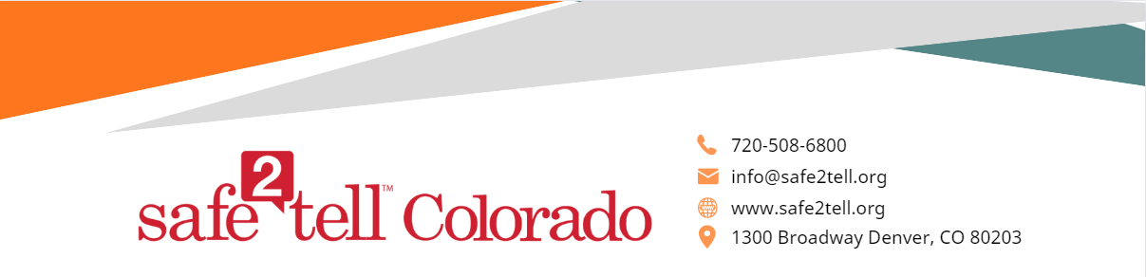

Dear parents, families, and school community,

Your students took part /will take part in a developmentally appropriate lesson on Safe2Tell Colorado on _________. We found Safe2Tell on the idea that early intervention is the key to preventing violence and saving lives. We developed Safe2Tell with the following principles:

- Educate - Encourage - Equip - Empower -

- Safe2Tell wants to educate the community on reporting safety concerns, break the code of silence and provide a trusted way for young people to make reports anonymously about things they may see or hear that cause concern.
- Safe2Tell aims to encourage everyone to play a role in prevention.
- Safe2Tell wants to equip our community with a direct way to report concerns anonymously.
- Safe2Tell empowers those who have the intention to help, prevent, or protect to make a difference.
We know that students often know about mental health concerns or safety concerns about their peers before adults do. We encourage students to be advocates for their community and be part of keeping everyone safe. Safe2Tell always encourages students to talk to a trusted adult first when they have concerns; however, we know it isn't always easy for students to speak up. The creation of Safe2Tell results from these challenges. It is a resource that aims to provide an anonymous way for students to make reports any time, any day. About 98% of reports submitted to Safe2Tell fall into the category of a good faith report and are actionable. False reports make up less than 2% of reports. The Information in a false report lacks evidence of an intent to help, prevent, or protect.

What do parents need to know about Safe2Tell?
- Parents can make a report themselves as well as with/on behalf of their child (ren).
- When submitting reports online, it is important to wait and engage in a conversation with the analyst in order to relay as much information as possible. (You do not need to have all the details to make a report.)
- Safe2Tell is the go between or middleman in order to get information from a reporter to the appropriate local school and law enforcement personnel. Safe2Tell does not investigate reports.
Important Things to Note:
- Safe2Tell can not notify the reporting party of the report outcome because of the anonymity of the program. All outcome information is private and autonomous to Safe2Tell.
- If you do not find satisfaction in the outcome of a report, Safe2Tell cannot enforce a different outcome. Please find the venue within your school district for escalating these concerns.
- Safe2Tell is not a resource for keeping a “record” of your school or child’s history and schools do not record reports in a child’s academic record.
- Safe2Tell accepts reports about youth in other states and countries, which are referred to the appropriate jurisdiction. When making the report, write Community at Large for the school/location.

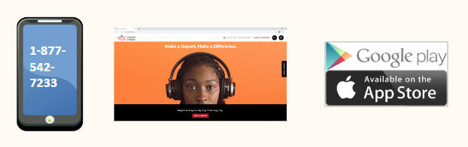
Where can you find Safe2Tell?


- Call us at 877-542-7233. We have an option to select a different language if needed.
- Find us at our website www.safe2tell.org
- Download our free mobile app

